NATIONAL RESTAURANT EXCHANGE
(617)721-9655
DSerpone@comcast.net

B.U. CAMPUS, BOSTON ~~FRESH PASTA- TO- GO
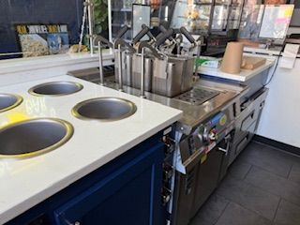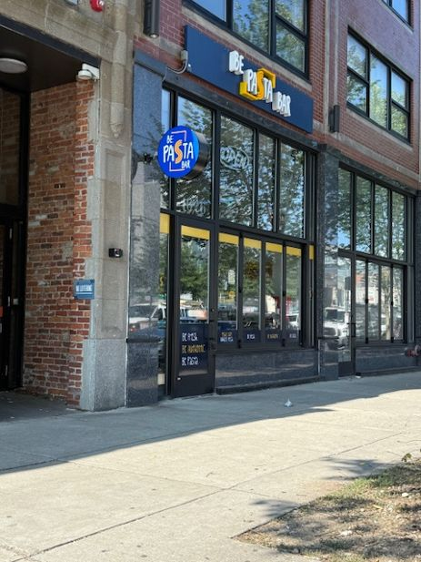
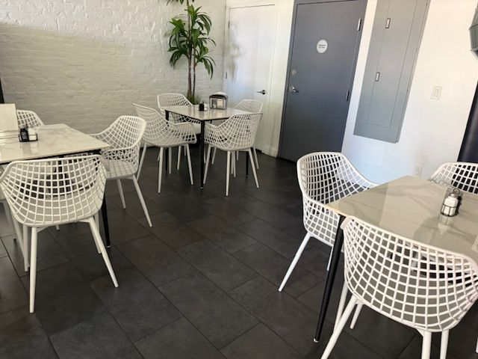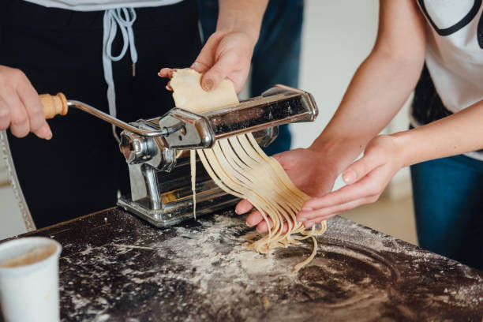
SELLING PRICE: $200K DOWN PAYMENT: only $100K

SALES VOLUME: $10K/wk Percentage Delivery: 50%

LEASE: $7,400/mo (includes NNN) …cheap for this college area / thousands of apts.
SQUARE FOOTAGE: 500 sf.; 3 flrs…beautiful kitchen in basement
HOURS OF OPERATION: 11 AM to 10PM, 7 days
SEATING: 12 seats 99% is p/u and delivery

REASON FOR SELLING: ABSENTEE OWNER has 3 other VERY successful pizza operations in downtown Boston.

COMMENTS: Built ONE YEAR ago…everything is brand new and top-of-the-line equipment. Simple, unique concept ready to franchise. Seller has not done any marketing.
FRESH PASTA, SANDWICHES, SALADS. Extensive food experience is not required…
NO COMPETITION!

Contact Bob at bobcioffi14@gmail.com, or call 781-820-9288.

