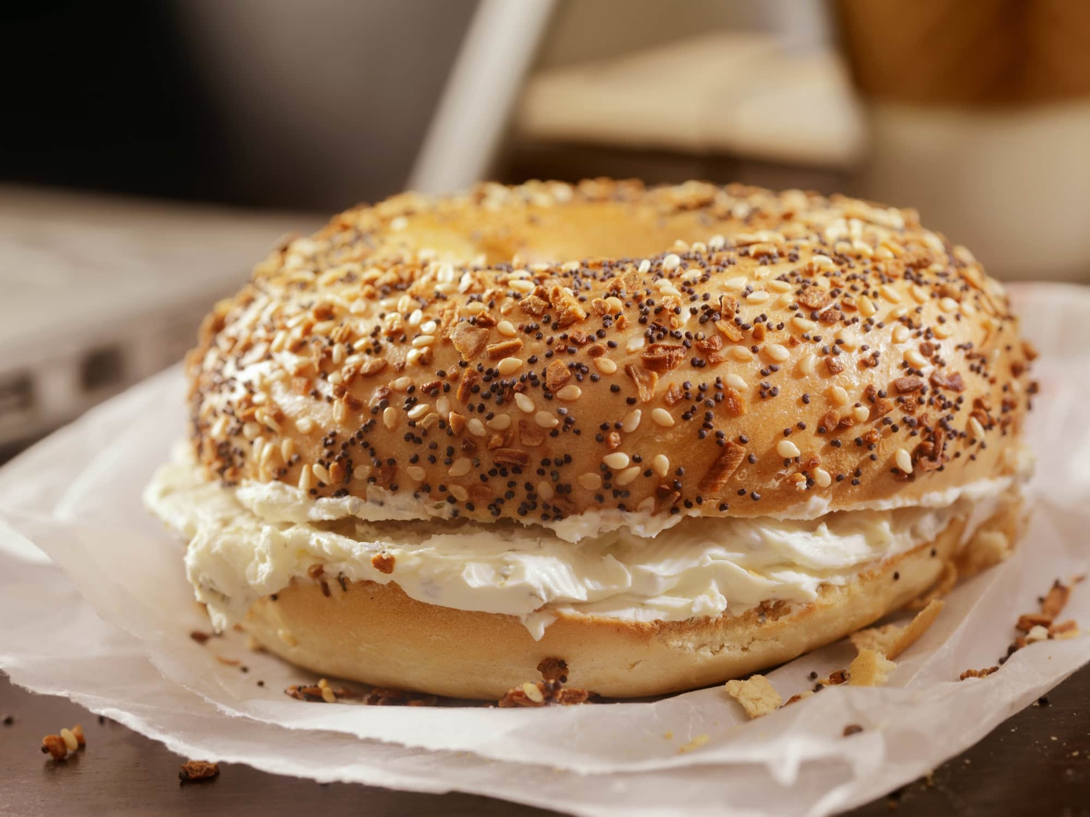

BAGEL SHOP in a SOUTH SHORE TOWN
Canton/Stoughton – HOMEMADE BAGEL FACTORY…BEST COFFEE IN TOWN
SELLING PRICE: $295K DOWN PAYMENT: $150K
SALES VOLUME: $12K/wk.
NO DELIVERY, NO SEATING, CALL PICK-UP
LEASE: ONLY $3,900/mo. (only 7% of your sales)
Years left: New Lease (5&5)
SQUARE FOOTAGE: 1,800 sf .
HOURS OF OPERATION: 7 days 6 am – 2 pm
REASON FOR SELLING: Retiring after 20+ years.
COMMENTS: Imagine yourself the owner of this thriving bagel and coffee shop on the area’s bustling retail district. Walk into your bakery each morning, greeted by the warm aroma of fresh bagels made daily by our experienced team. The current owner has built systems that allow minimal hands-on time while maintaining quality and profitability.
You’ll appreciate this prime location surrounded by national retailers and local businesses that drive steady foot traffic throughout the day. This established bakery has a customer base, location, and operational foundation solidly in place. You’re not starting from scratch. The bagels are clearly the star attraction for over 20 years, and with your team’s proven ability, the tradition will continue seamlessly under new ownership.
Your down payment will be back in your pocket in the first year!!!
Call John @ 781-858-2343 or email jkruggie@comcast.net

