NATIONAL RESTAURANT EXCHANGE
nerestaurants@yahoo.com

LISTING INFORMATION

HARVARD Sq.-INMAN Sq-FAMOUS SANDWICH SHOP
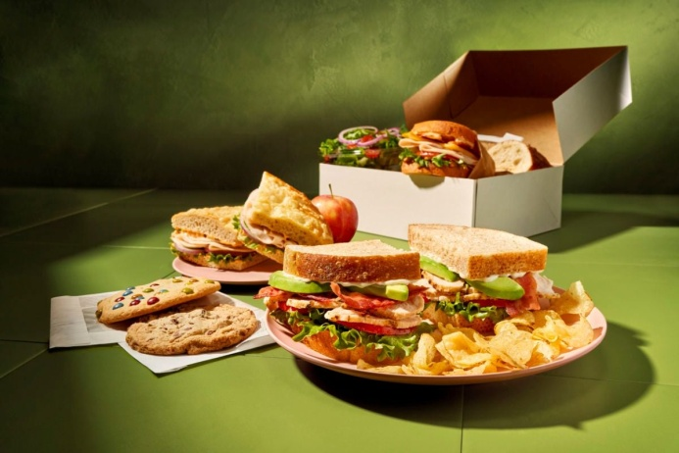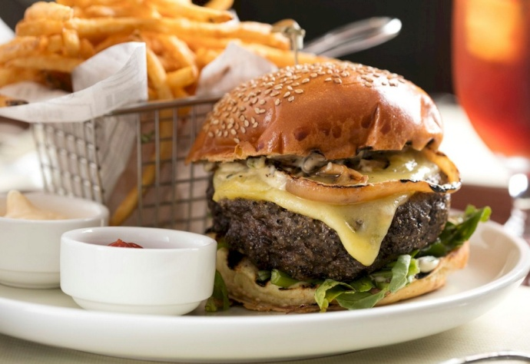

SELLING PRICE: $699K Accurate financial records ensure SBA financing with
only $100K dn.
SALES VOLUME: $35K/wk.

LEASE: $7K/mo. (includes NNN)
YRS. LEFT: 5 yrs…great landlord will write more time.

SQUARE FOOTAGE: 1,100 sf.

SEATING: 31 seats

HOURS OF OPERATION: 7 days, varies slightly 11AM – 9 PM

VERIFIABLE ANNUAL NET INCOME: $263,000/yr. (15% of sales)

COMMENTS: This is an UNBELIEVABLE opportunity for a hands-on seasoned operator. Present owner is ABSENTEE. Besides a strong pick-up business, the Door Dash deliveries are about 30% of sales, and a quickly growing catering business with all the local colleges.
Winner of the coveted BEST SANDWICHES IN CAMBRIDGE award. Seasoned staff will stay after sale. Your $100,000 down payment will be back in your pocket in the first year. YOU NEED TO SEE THE FOOT TRAFFIC FLOWING BY THEIR DOOR.

