NATIONAL RESTAURANTEXCHANGE
(978)-715-5405
nerestaurants@yahoo.com

LISTING INFORMATION
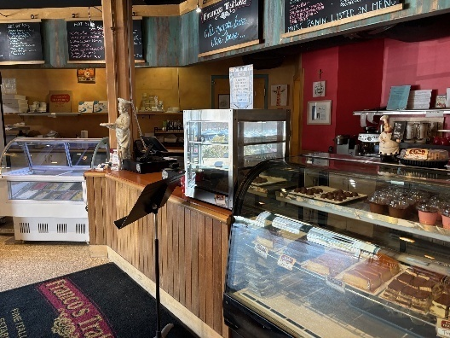
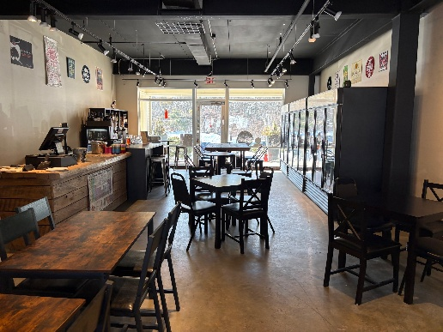
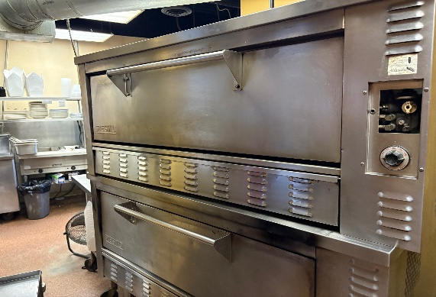

TYPE OF BUSINESS: Italian Trattoria

LOCATION: Greater Wayland Area

SELLING PRICE: $525,000 DOWN PAYMENT: $200,000

SALES VOLUME: $23-25K/wk. 25% Delivery

LEASE: $5,900 / mo. (includes. NNN) Years left: 3yrs. + 5 option

SQUARE FOOTAGE: 4,000+sf. .. basement set up for prep

HOURS OF OPERATION: 6 days, 11-9… closed Mon.

SEATING: 40seats in restaurant, /48 seats in the pub, and 10 seats on patio

COMMENTS: Here’s a twofer you must see to believe. NOTHING IS MORE PROFITABLE THAN PIZZA AND BOOZE.
A VERY popular Pizza Parlor with a Beer and Wine Lounge just a few steps away. Bring the kids for pizza and gelato while you sit and enjoy a glass of wine or a craft beer. Oh, and enjoy local entertainment Thurs thru Sat. nights. Enjoy stone hearth Neapolitan pizza, pasta and traditional Italian dishes in cozy family atmosphere. It offers children a table for playing with crayons and their own 60 “TV. Kitchen is in impeccable condition and a storage room in the basement with a walk-in cooler and freezer. This is too good to believe.

