NATIONAL RESTAURANT EXCHANGE
(617)721-9655 Fax: (781)246-5000
DSerpone@comcast.net

LISTING INFORMATION

MARSHFIELD-BEACH AREA—CONVENIENCE STORE/ BEER & WINE
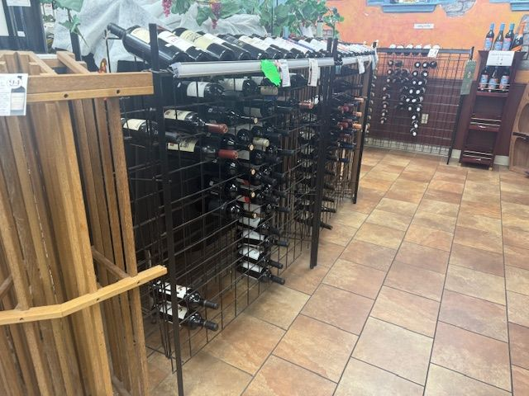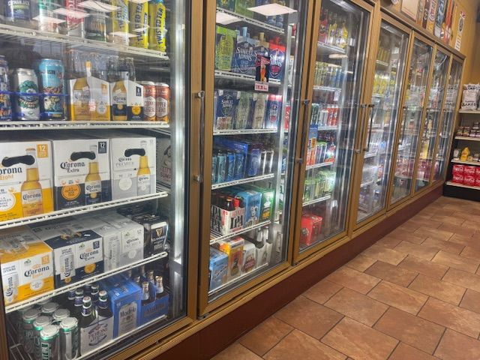

SELLING PRICE: $100,000 DOWN PAYMENT: only $50,000

SALES VOLUME: Consistent sales of $600K per yr. (no delivery)

LEASE: $4,300/mo (includes NNN) YRS. LEFT: 2 yrs + 5 yr, option

SQUARE FOOTAGE: 2,000 sf.

HOURS OF OPERATION: 8 am – 8 pm

ANNUAL LOTTERY COMMISSIONS: $15,000

REASON FOR SELLING: family health issues

COMMENTS: This is a rare opportunity to purchase a c-store in a very affluent town on the main road to the beach and docks. Simple and fast breakfast and lunch sandwiches, a store with an excellent selection of beer & wine, and the usually C-store products. There’s room to expand either the wine or convenience items. Large, dry basement with walk-ins and supply storage. This is PERFECT for a husband/wife team or a couple of guys. Time to own a second store and welcome a new spring. This a a popular stop on the way to the beach.

