NATIONAL RESTAURANT EXCHANGE
978-715-5405 FAX: 339-883-3027

LISTING INFORMATION

NEWTON~~FAST CASUAL specializing in pizza, sandwiches, and dinners to go.
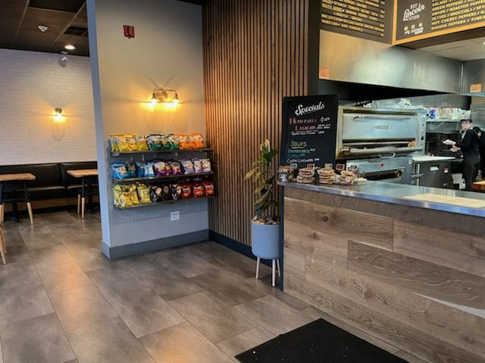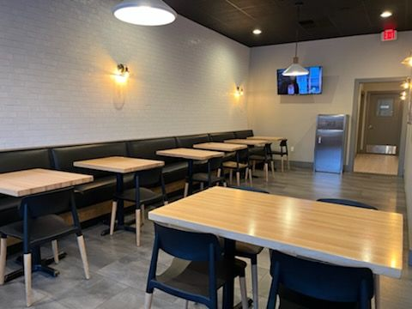
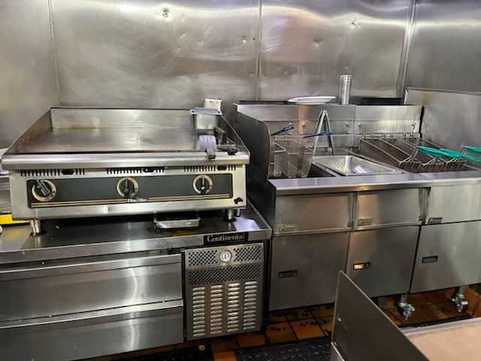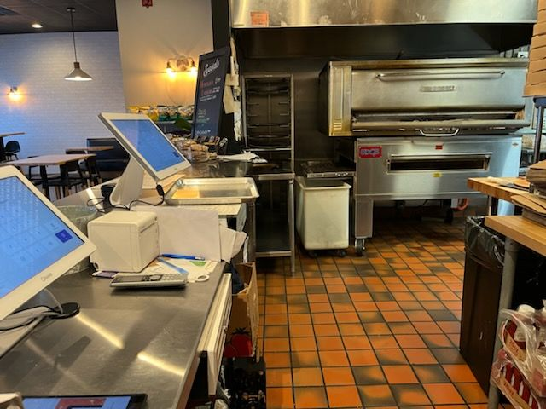

SELLING PRICE: $150K DOWN PAYMENT: $100K

PRIOR SALES VOLUME: $17K - $18K/wk
LEASE: $4,250/mo. + NNN (7% of sales) Years left: 2 yrs. + (2) 5 yr. options

SQUARE FOOTAGE: 2,300 sf. + full dry basement with walk-in refrigeration

HOURS OF OPERATION: 6 days, 11 am – 9 pm (RECENTLY CLOSED)

SEATING: 30 seats (inside) 8 seats (outside)

COMMENTS: This is an amazing operation with enough equipment to handle any menu.
You’ll be amazed at the quality of the design and choice of equipment. Opening Sundays could add $3K per wk. Business has netted over $125K/yr. while it was open. Newton is one of the most affluent markets in Mass. Your cash investment is returned in the first year.

